The Teaneck Route 4 Open Space Historical District (Teaneck Route 4 Greenbelt)
A. Citation of selected relevant Township and related decisions
The Greenbelt - What is it?
Since the development of the Township’s first Master Plan in 1933, the Teaneck’s governing body, statutory land use and other boards and commissions have regularly supported the preservation of the tree-lined open space corridor along State Route 4 – its Greenbelt - and have worked to acquire and protect largely publicly-owned land along Route 4 stretching from the Englewood border to River Road, using taxpayer funds and with the assistance of the State of New Jersey.
How have Teaneck Councils described it and its purposes:
Resolution 118-87- in response to highway plans deemed detrimental to the Greenbelt
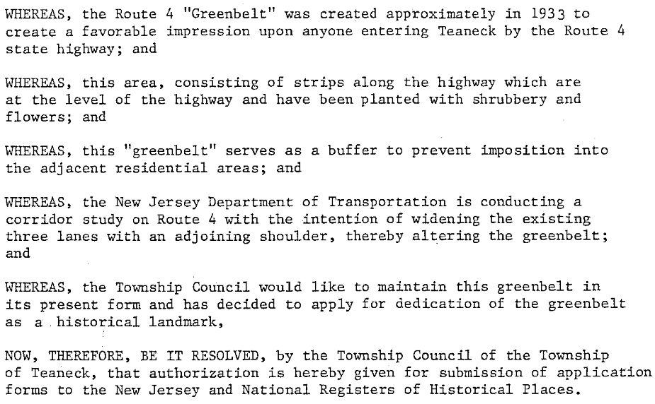
Resolution 254-91 - again, in response to highway plans deemed detrimental to the Greenbelt (same as 285-84)
Council affirmed that “Since the highway was constructed in 1931, the Township has preserved the Route 4 greenbelt for its intrinsic beauty and to symbolize Teaneck’s self-image as a residential community which safeguards against commercial exploitation of its open space. The 1933 Master Plan and succeeding planning and zoning have adhered to this principle and reaffirmed this objective.”

Resolution 331-03 – again in response to evolving highway renovation plans
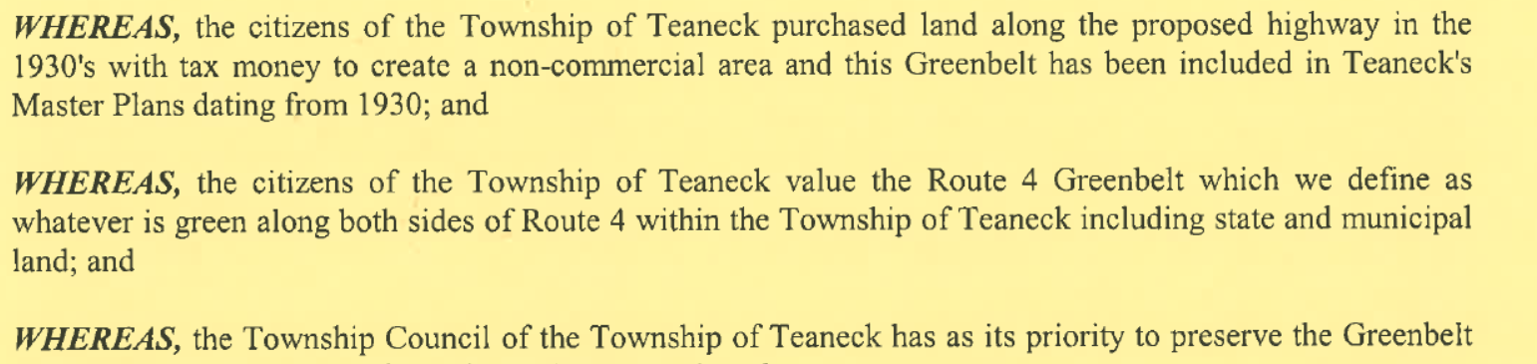
Resolution O – 8/16/2011 In response to a Master Plan Re-exam calling for 2 hotel zones on the Greenbelt
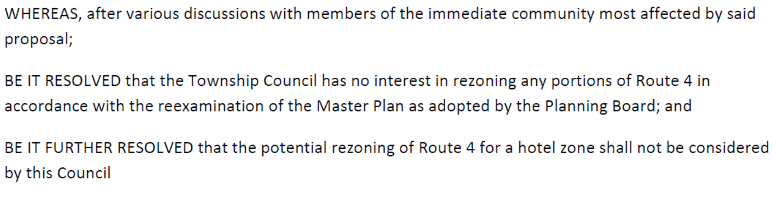
How have Selected Teaneck Master Plans described the Greenbelt:
1992 Master Plan – likely referring to the 1987 Council resolution 118-87 (see above)
“The following historic [8] sites which have been designated by Township Council and which are listed by National and/or State Registers are included in the Master Plan by listing and by identification on the attached map, Plate 32”
“The Route 4 Greenbelt deserves special mention since it is a linear district involving public land. The Land Use Plan continues to support a zoning pattern which will not place undue pressure on the Greenbelt, which could occur if nonresidential zoning or development were encouraged.”
2007 Open Space & Recreation Plan (OSRP) incorporated into the 2007 Township Master Plan, the Township’s most recent full MP
“Open space and recreation have been important to Teaneck since the early 1930s when the Township's Master Plan recognized the benefit of establishing a greenbelt along the new State Route 4. This greenbelt presently runs along both sides of Route 4 and offers a quiet buffer of trees and green-space to residential neighborhoods that hug the Route 4 corridor.”
“Teaneck has always had an interest in open space and aesthetic beauty. It is the only town along the State Route 4 corridor that does not have any commercial development. Rather, the Township and the State of New Jersey have created a greenbelt/buffer area.”
(Note: This OSRP lists 127 separate Block and Lots specifically defined as “Route 4 Greenbelt”, among which are the specific Block (4102) and Lots (26.01 and 27) now proposed by the 2017 Master Plan Re-examination for Self-Storage/Office Building rezoning.
Chronology of Other Recent Official Body Actions Describing and Supporting Preservation of the Greenbelt – gathering momentum today.
4/19 2007 -Bergen County Historic Site Survey – Historic Site #0260-59
“It is probable that the Teaneck Route 4 Greenbelt district is eligible for listing on the State and National registers of Historic Places due to its importance as a cultural landscape in the statewide context of Metropolitan New Jersey.”
2013 Environmental Resources Inventory Update – Teaneck Environmental Commission and the Land Conservancy of NJ – initial 2 sentences in its Executive Summary:
Conservation of natural resources has been important to Teaneck Township since the early 1930’s when the Township’s Master Plan recognized the benefit of establishing a greenbelt along the new State Route 4. This heavily-wooded greenway runs along both sides of Route 4 and offers a quiet respite of trees and green space that adjoin the Route 4 corridor. (Note, on June 21, 2017 the Teaneck Environmental Commission approved a resolution opposing the rezoning of Block 4102 to allow a Self-storage facility on the Greenbelt which it considers to be protected Open Space)
2014-16 The State Historical Preservation Office– took three steps in order to achieve full national historic district protections for any federal highway undertaking covered by Section 106 and to find the Greenbelt eligible for NJ and National Registers of Historic Places (March 2015, September 1, 2015 and September 13, 2016) Note: on June 20, 2017 the Teaneck Historical Preservation Commission approved a resolution to be sent to the Township Council recommending that the Township pursue listing the Greenbelt on the National Register of Historic Places for which it has been declared eligible.)
It is viewed as very likely that the Township’s Greenbelt Committee will at its next meeting on June 29, 2017 recommend to Council that it not approve Ordinance 13-2017 to rezone Block 4102, Lots 26.01 and 27.

B. Narrative: a discussion seeking to clarify the validity of Teaneck’s Fall 2010 claims that none of the properties on the Township’s Greenbelt are – and not the Greenbelt as a whole is – eligible to be placed on the municipality’s Recreation and Open Space Inventory (ROSI). It also seeks to determine whether recent decisions about the Teaneck Greenbelt as an “Open Space Historic District” shed any light on those 2010 assertions and subsequent ROSI decisions. At work throughout this discussion is not only the issue of whether the entire Greenbelt should have been placed/should be placed on the ROSI but more narrowly whether the specific properties now proposed for zoning change from R01 to Self-storage may deserve a priority re-evaluation in light of impending Township decisions affecting their allowed use.
What are Appropriate Uses and Purposes of Open Space Properties and Historic Districts? The Greenbelt’s current status and new eligibility for additional status and protections as a registered historic district means that any proposed changes to the Greenbelt properties must be shown to be changes that represent “appropriate uses” for an historic district of any specific type.
So what are the appropriate uses of Teaneck’s Greenbelt properties? The answer requires understanding for what purpose the Township has been protecting, preserving, and making investments (including the extensive public purchase of Route 4 buffer property) for 86 years – literally since 1931?
An answer to that “what was/is the purpose?” question should help us all understand one other key issue: Why is the Teaneck Route 4 Open Space Corridor Historic District (Teaneck Route 4 Greenbelt) currently not on the Township’s Recreation and Open Space Inventory (the ROSI). Were it on the ROSI, only Greenbelt property uses consistent with “recreation and conservation” would be allowed by the State. Were the Township then to permit any non-conforming use could cause Teaneck to lose access to all the State’s Green Acres funding – from which it has greatly benefited in the past and can be expected to benefit in the future!
So who decides what properties should go on any municipality’s ROSI? The simple answer is, the ROSI is an inventory on which properties are deemed “recreation/conservation” properties that BOTH the municipality and the State agree are the “conservation/recreation” properties that should be placed there. Why? Because the State and municipal ROSI lists must be reconciled – or be identical – if a municipality is to be eligible for Green Acres funding. (see. N.J.A.C. 7:36-25.3).
It turns out that the last time that State/Teaneck “ROSI reconciliation” occurred was in November of 2010. The Township was then seeking final approval of a $750K funding project ($600K of which was to be a grant) from the State’s Green Acres for Teaneck’s new Sportsplex. That large Green Acres funding project could be approved ONLY if the State and Township had an agreed (a “reconciled”) ROSI.

That is why – reportedly after months of “behind the scenes” negotiation [Broughton] the Green Acres state employees who oversee the State’s ROSIs database came to Teaneck in early November 2010 with questions about whether Teaneck’s ROSI was complete. One of their issues was whether the Greenbelt should be added to Teaneck’s ROSI. And the right answer would depend on what is the purpose of the Greenbelt and its properties!
We now know what the 3 Teaneck employees told the Green Acres database compliance officer, Nancy Lawrence, because two weeks after her visit and consultation she wrote an email (11/23/2010) confirming the results of thpse “ROSI reconciliation” discussions. In the final section of the email, Compliance Official Lawrence agrees not to insist that the Greenbelt be placed on the ROSI. Even though she cites many of the precise characteristics that would require placing Greenbelt properties on the ROSI (aesthetics, buffering from development, etc.), her email then cites what she calls “the fact” – apparently asserted to her by the Township officials – that the real imperative or function served by Greenbelt properties was/is to “protect this road as a high-speed thoroughfare”. Hence, presumably, that is why “conservation/ recreation” was not deemed by both Green Acres and the Township to be the Greenbelt’s controlling purpose. To see the complete email click here. The most relevant portion of that email is found below
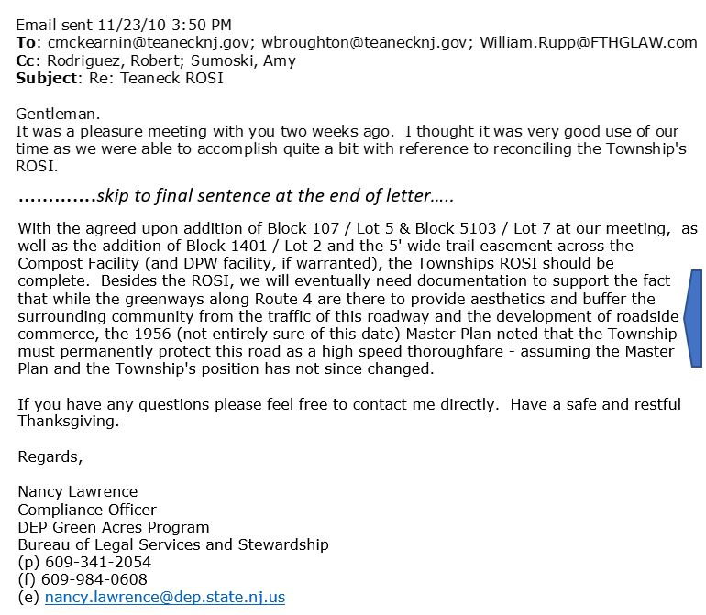
To whom in Teaneck did the Teaneck officials explain that this was the definition of the Greenbelt that they had just given to the Green Acres Compliance Officer? Who knew or was told that it was only because the Greenbelt’s purpose had become its role in expediting Route 4 as a “high-speed thoroughfare” that Green Acres had backed off requiring that it be placed on the ROSI? Apparently no one, at least publicly. Click this web address (https://youtu.be/mOH9Mvp8OZk) to see the video of Manager Broughton and senior Township Attorney Turitz describing the ROSI negotiation to the Teaneck Council on 11/30/2010. It is apparently the only briefing either the governing board or the public ever got about the ROSI negotiation matter. You will note in watching the 7-minute video that the two officials provided not the slightest hint that there was any issue related to the Greenbelt during the ROSI reconciliation negotiation. Nothing is said in the 11/30/2010 informal report to Council about the rationale the Township had given for excluding those Greenbelt properties from the ROSI. This video raises serious issues about how open and transparent these officials were with the Council, let alone with the residents. We are looking but find no evidence that there had been or indeed ever has been in the intervening 7 years since 2010 any explanation of the criteria the Township’s officers have adopted when evaluating the inclusion of properties on the ROSI – except that the officials claim to review governing board ordinances and resolutions – a procedure NOT followed when explaining why the Greenbelt properties were excluded , The video raises intriguing issues about the consistency of the Township’s use of its own criteria; even more serious is how much those criteria vary from State law and regulation about ROSI inclusion,
But we should not get lost prematurely in what the Teaneck Administration told Council. As we have seen from the Lawrence letter of 11/23, it was what Township officials in 2010 told Green Acres about the “high-speed thoroughfare” definition of the Greenbelt’s function/purpose that had actually turned the tide with Green Acres. But we are confident, that that depiction of the Greenbelt’s rationale would have/will come as complete surprise to Teaneck officials and residents who have served for decades on the front lines to defend the actual Greenbelt. Many official bodies and parties, surely including NJ’s DOT, will find the idea that the Greenbelt’s primary function is to improve “high speed thoroughfare” as not merely laughable but utterly ironic. The Township has worked for nearly all of the 86 Greenbelt years to get the recognition of the Greenbelt as a natural resource worthy of protection from what the Town has perceived as an often over-zealous pursuit of highway efficiency or commercial development at the expense of the Greenbelt. Thus, the very recent SHPO “finding” about the Greenbelt as an historic “open space” district and the new commitments to Greenbelt protection found in the consequent tri-party MOA is being greeted a victory for the Township’s longstanding Greenbelt advocacy.
But irrespective of whatever it was that the three officials to whom Compliance Officer Lawrence was writing had told her, her letter specifically said she still required documentation – and specifically documentation from the Master Plan the Teaneck officials had referenced in their discussion. (Remember – ironically, in the video you have just heard Attorney Turitz dismiss the authority of any Master Plan inventory. But it was to a Master Plan that the Styate was told to look to validate their clkaim about the Greenbelt’s purpose) And what documentation did the Township officials then send Compliance Officer Lawrence in response to her email’s request? Nothing. That is the State has no record of that 11/2010 requested “documentation” ever having been provided – at least as of May 2017. [personal communication from Green Acres].

The Township did, however, less than two months after Ms. Lawrence’s letter (1/6/2011) move ahead to provide some different documentation — a signed certification – a Declaration – from the Manager and the Planning Board Chair. Included in the Declaration was the Township’s ROSI list- and as expected it omitted the 192 “Route 4 Greenbelt “properties that had been specifically identified by Block and Lot when cited in the 2007 Open Space and Recreation Plan (Note: that Plan had been incorporated in 2008 into what still today in 2017 Teaneck’s most recent full Master Plan approved by the Planning Board in 2007). What must a municipality certify about the ROSI they included? Answer: that its ROSI is “a complete and accurate listing of all lands held …..for recreation and conservation purposes.” Actually, the state’s declaration form is quite clear in several places that ALL eligible recreation and open space properties are to be included – and that failure to do so would result in specific statutorily defined penalties (see Image of declaration clip immediately below and for the entire declaration click here)
But what would it take to convince the State in 2017 that the 3 officials who in a professed effort to keep the ROSI inventory limited had given the State a misleading definition of the function of the Township of the Township’s Greenbelt properties.
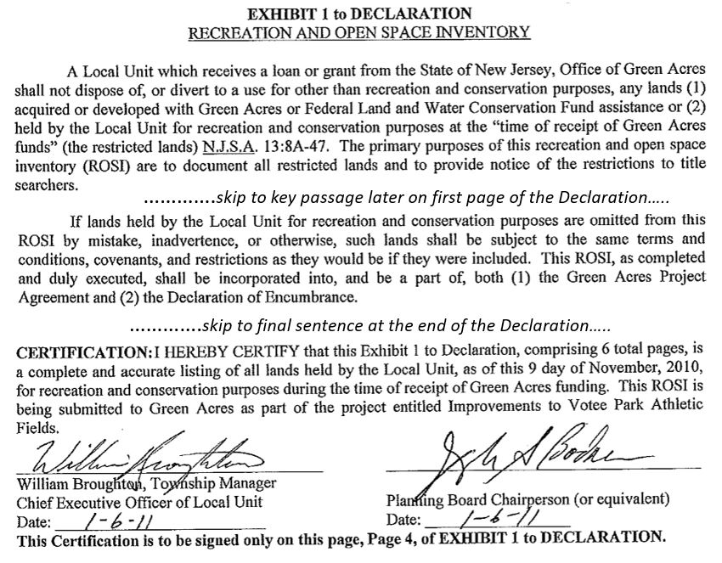

What have we learned so far about Teaneck’s Greenbelt and whether those properties deserve ROSI “use” protections.

A) Clearly “thoroughfare protection” is not what hundreds of Teaneck documents say was/is the Greenbelt’s purpose and its role in the identity and life of this suburban community. Instead, three concepts very much at variance with this “thoroughfare” definition are consistently found as the rationale and purpose that the Town claimed/claims as its reason to have created and protected the Greenbelt throughout a 86 year history: 1) the Greenbelt is for open space and natural resource conservation; 2) it is for residential parkland buffering; and 3) it serves to prevent commercialization along the highway – a purpose driven by Teaneck’s repeatedly stated goal of NOT ever becoming “like” what the commercialization of Route 4 in Englewood to the east and Hackensack to the west was becoming/has become. As seen above. we have cited just some of the many quotes about the Greenbelt definition and rationale from 1) Council resolutions; 2) from Master Plans; 3) from key resource and open space inventories. We believe the consistency of these completely different statements of Greenbelt purpose invalidate the apparently offhand and undocumented verbal statement of a completely inconsistent purpose made to a compliance officer in 2010?
B) A review of the two Township documents where the concept of “thoroughfare” protection was in any way cited shows that the concept of the relationship between the Greenbelt as an aid to a high speed thoroughfare was first suggested by a NYC Consultant in 1947 (who likened what he saw in Teaneck to parkways he had helped plan in southern Connecticut). But he then explained that its preeminent purpose was to strengthen the prohibitions against pressures for commercialization – and like all of his planner predecessors railed against cheap commercial developments in the communities to the east and west of Teaneck and saw what he called the Greenbelt’s “park strips” as “maintaining the integrity of the Town Plan” which he viewed centrally as its strong commitment to parks and open space. We know of only one other official town document where the Greenbelt is even indirectly cited for a contribution to traffic management – but does so in context of again citing its prophylactic function against commercialization. (The General Development Plan, 1962):
Through the foresight of Teaneck citizens, all of the abutting right-of-way not owned by the State was purchased by the Township primarily for the purposes of restricting commercial development. Today this right-of-way provides the opportunity for improving access by the provision of improved ramps and allowing for limited deceleration lane construction.
http://www.teaneck.org/virtualvillage/TeaneckDevelopmentPlan/circulation.html
C) Any analysis of how Teaneck officials and entities have argued in behalf of the Greenbelt when confronted with highway project proposals whose purpose and implementation might improve Route 4 as a thoroughfare but involve Greenbelt losses show a consistent pattern. Teaneck officials drawn into dialogue with transportation planners were “there to” and did made arguments precisely to preserve the Greenbelt. While concerned with safety and related highway efficiency issues, they were not there with the purpose of helping deploy the Greenbelt to aid “thoroughfare” efficiency. A good example is the Teaneck Greenbelt Committee whose charter might seem to suggest a dual purpose.
“Teaneck Greenbelt Committee: “The Committee was formed to protect the open space known as the “Greenbelt” along Route 4 in Teaneck by working with Township officials and NJDOT to improve safety and traffic flow along the highway. It has also been agreed that any land taken from the Greenbelt for highway improvements should be compensated by the State in the purchase of equal open space land within the Township.”
Open space is what the Committee protects; it is that for which it will seek compensation for loss. Particularly in the 80’s and 90’s this Committee sought ways to save Greenbelt open space while trying to find compromises with an aggressive NJ DOT], But the Committee was outraged and reinvigorated when in 1997 an un-permitted NJDOT project removed over 500 trees. (When the current Committee meets on June 29, it is widely expected to issue a strong resolution opposing the proposed Self-storage facility.).
D) There is an argument to be made that those 3 officials who sought to exempt the Greenbelt from the ROSI were operating beyond their authority. In Faulkner Law municipalities governing boards make policy. We have sought and not found any Council action during the 2010 time frame either to authorize this “thoroughfare” enhancement definition of the Greenbelt’s function and purpose or to authorize these officials to state that definition. (Note Attorney Turitz does not in the short 11/30/2010 video discussed above cite ANY authority when stating ex post facto that “the Township has taken the position….”). Indeed that definition is inconsistent with any official Teaneck governing board action of which we are aware. We believe the three Teaneck officials lacked either a documentary basis for their statement of Greenbelt property purpose or the authorization to articulate it as they did in this November 2010 setting.
Compliance officer Lawrence was understandably relying on the veracity of the three officials’ word for the Greenbelt’s purpose but noted “assuming the Master Plan and Township position have not changed since”.
Changed Since When? Ms. Lawrence could have meant two possible time frames.
1) “Changed” since the referenced 1956 Master Plan (the document never sent, remember)}
2) But maybe Ma. Lawrence meant a much narrower and more recent time frame. That would focus attention on whether the decisions/actions taken by official Township bodies in the 2010 time frame – or indeed during 7 year period beginning in 2010 to the present – would validate the Town’s use of Greenbelt property primarily to contribute to Route 4 as a “high-speed thoroughfare”. However,
- Within literally seven days of the receipt of the Lawrence email in which the Compliance Officer relies on their being Master Plan documentation to prove the Township’s assertion, Mr. Turitz told Council such Master Plan documentation would in no way validate anything about Township open space land use issues. Attorney Turitz had totally dismissed Master Plans and their ilk as representing legitimate/legal sources for determining what properties are open spaces ones; such documents are advisory until incorporated in governing board decisions. We do not know why the requested documentation was not sent. (Note: I have received notice from the Township Clerk that my 6/2/207 request for records both of Township correspondence to Green Acres in response to its documentation request and for a copy of the 1956 Master Plan cited in the Lawrence 11/23/2010 letter will 4 require extensions of 25 and 30 days to enable the Clerk to locate the requested records. )
- Just 6 months later after the Teaneck/Green Acres ROSI discussions – in early May 2011 – Township Planner Richard Preiss delivered his 32-page 2011 Master Plan Re-examination report which called for commercialization of almost 9 acres of Greenbelt property (most of it town owned) as hotel zones in roadside properties on either side of Route 4 near the Englewood border. Several weeks later (5/25/2011), with the change of one word (“would” to “could”), that report was adopted unanimously by the Township’s Planning Board. And yet the specifications for the hotel zones recommended zoning changes that involved curbside commerce inconsistent with, for example, any road widening or thoroughfare enhancement and 2) would unquestionably have turned the primary function of those Greenbelt properties into precisely the commercialization that Teaneck had for 86 years given as one of, if not always, the primary reason for protecting Greenbelt open space Resident outcry in 2011 soon caused the Township Council entirely to back off this commercialization. in August 2011. (See Resolution O. But it can be demonstrated that completely absent from any of these 2011 discussions was any hint of interest in the Greenbelt serving Route 4 traffic efficiency.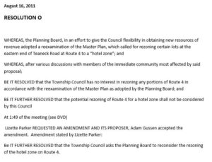
In none of the succeeding 6 years has this fundamental inconsistency between what Teaneck had told Green Acres was its Greenbelt property purposes and the commercial alternatives some Township officials have pursued. Clearly the only rationale offered by Council members was whether the alternative was likely to generate enough municipal revenue [“ratables”] to justify weathering the certain resident public critique when the Township began yielding its open space. Was Council ready to resist – as one attorney and Council member called them – “the tree-huggers” (relevant portion of the official public recording of this session is available on request).
Put simply, the Greenbelt land uses proposed (none are yet finally approved) changes since 2010 are now devoted to allowing Greenbelt open space properties to become hosts to: hotel zones, a 672 sq foot double-sided multi-message billboard and a large self-storage facility (whose entrance would surely impede Route 4 traffic). The Self-storage facility described in Ordinance 6046 would obstruct any additional lane added to Route 4.
There is simply a disconnect between the purposes and rules which govern the Green Acres ROSI inclusion requirements and the shift in Greenbelt property commercialization uses currently being pursued by some in the Township leadership. By the clear reading of Green Acre ROSI listing regulations, the status of properties which have been recreation/conservation lands and have been placed or should have been placed on a municipality’s ROSI are to remain so defined. No township is required to have sought Green Acres funding – and so long as its certifications to the State have been accurate – municipalities can opt out of eligibility for Green Acres funding as long as they keep what have been their commitments. We question whether Teaneck Township followed those rules by giving accurate certifications. Now, having taken major recreation funding and seeking to stand in line for more, is it simultaneously poised to be in ever increasing “non-compliance”? The Township’s jeopardy has been heightened significantly in the past 3 years as the SHPO program has aligned its concern for the Greenbelt’s historical preservation with surveys and findings which in identifying as worthy from an historical point of view the same precise open space (recreation/conservation) characteristics that are central to the Green Acres ROSI definitions and regulations. Again, the name of the historic district defined and now being accepted as an integral element in highway planning is “The Teaneck Route 4 Open Space Corridor Historic District” (Teaneck Route 4 Greenbelt)
At the very least, it surely is time for those in charge of oversight of the integrity of the Green Acres program to seek clarification from the Township’s officials about all of the issues raised herein and take these matters to whatever is their appropriate resolution. It is the DEP’s central mandate to assure appropriate use of these valuable NJ recreation/conservation properties.

